ACCOMPLISHMENT REPORT
IT 407 & 407L –Geographic Information Systems
Month: December – Year: 2025
School Year: 2025 – 2026 1st Semester

DATE | ACCOMPLISHMENT | REMARKS  (Progress and deviations from the plan) *
December 1 - 5, 2025 | Lecture Accomplishments:  - Finalized Module 3 discussions on heat maps by consolidating parameter selection (radius, weighting, kernel settings) and linking outputs to decision-making contexts (risk, accessibility, demand).  - Reinforced cartographic and ethical standards for density maps (color ramp choice, legend clarity, scale sensitivity, and responsible communication of hotspots).  - Facilitated case-study synthesis/discussions where students justified hotspot interpretations, documented assumptions/limitations.  Laboratory Accomplishments:  - Supervised refinement of case-based heat maps in QGIS, including correct projection handling, layer context integration (boundaries/roads/land use), and consistent symbology.  - Required students to complete a print-ready layout (title, legend, scale bar, north arrow, notes, and data source citation) and export final outputs (PDF/image).  - Collected final case-study deliverables: polished heat map layout + brief written interpretation (findings, limitations, and recommended actions).  - Conducted peer review and instructor validation to ensure outputs meet technical and cartographic standards. | Accomplished  (Final polished heat map layouts and discussion interpretations were completed as concluding outputs for Module 3; students are prepared for Finaltern examination.)
December 8 - 12, 2025 | Lecture Accomplishments:  - Administered the Final Term Examination covering concepts and applications from Modules 3, with emphasis on thematic mapping standards and heat map interpretation.  - Completed checking and initial recording of examination results for consolidation.  Laboratory Accomplishments:  - Conducted the practical/skills assessment requiring students to generate a heat map from a point dataset, apply appropriate parameters, and produce an exportable print layout within the allotted time.  - Validated outputs using rubric-based criteria (data preparation/projection, parameter justification, symbology/legend design, layout completeness, and interpretation quality).  - Recorded Finak exam scores and documented common errors for feedback. | Accomplished  (Final written and practical examination were completed)
December 15 - 19, 2025 | Lecture Accomplishments:  - Finalized checking of lecture requirements (activities/quizzes/outputs/exams) and consolidated final lecture grades.  - Conducted consultation/feedback sessions to address student clarifications and reinforce improvement points based on assessment results.  Laboratory Accomplishments:  - Finalized checking of laboratory outputs (Module 3 heat map layouts, case-study interpretations, and practical exam artifacts) and consolidated final laboratory grades.  - Organized, labeled, and archived objective evidence (rubrics, sample outputs, exported maps, and score sheets) for semester closure and quality audit readiness. | Accomplished
*Provide relevant documentation such as pictures, summary reports, etc.
Prepared by: Approved:

JUNNIE RYH M. SUMACOT SHERWIN G. CADAY, PhD.
Instructor Program Chair
PROOF/EVIDENCE OF REPORTED ACCOMPLISHMENTS
IT 407 & 407L –Geographic Information Systems
Month: December – Year: 2025
School Year: 2025 – 2026 1st Semester

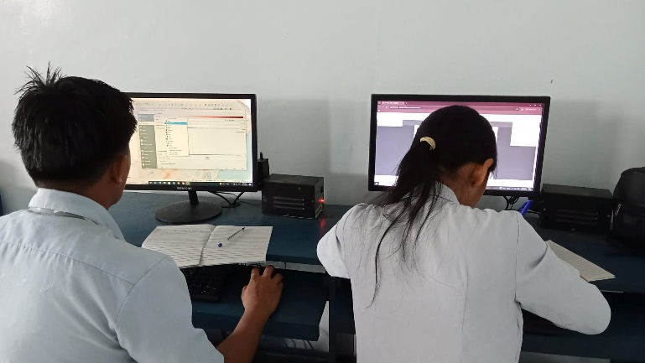
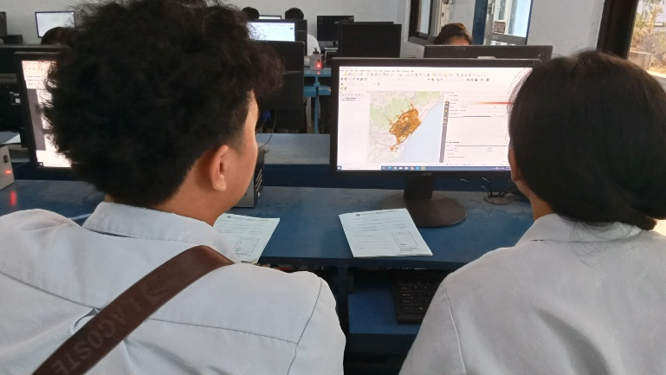

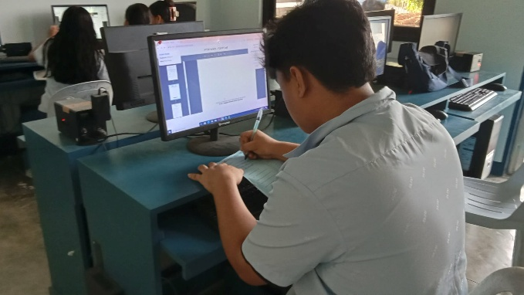

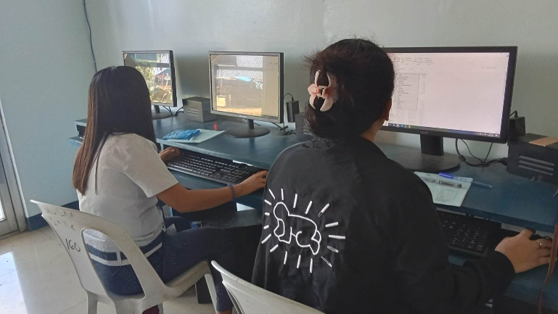
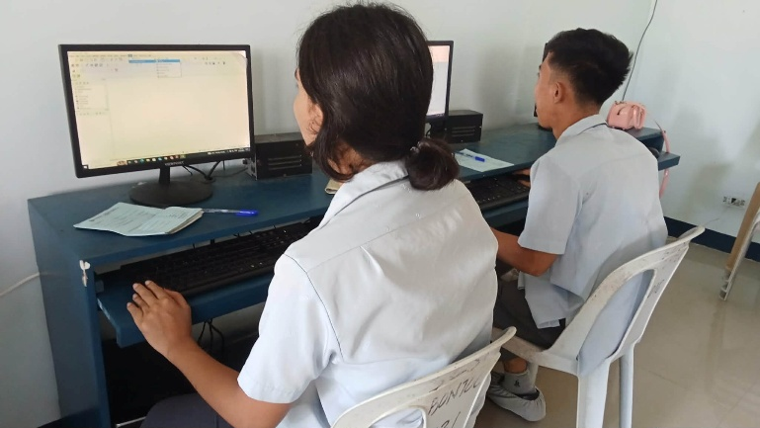

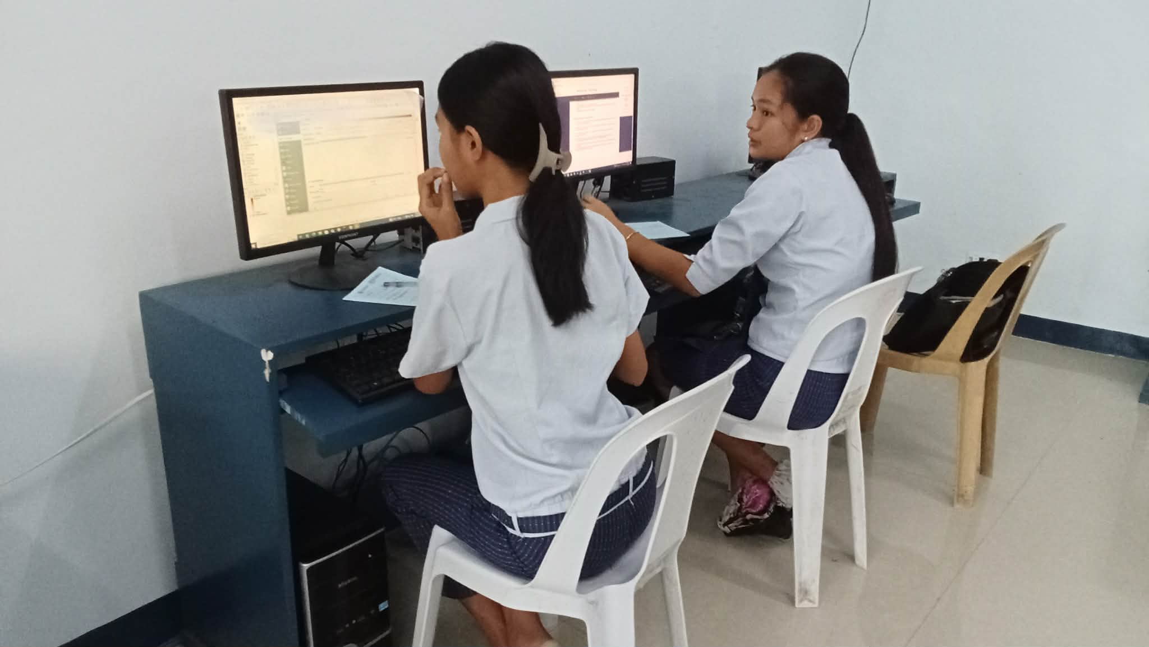
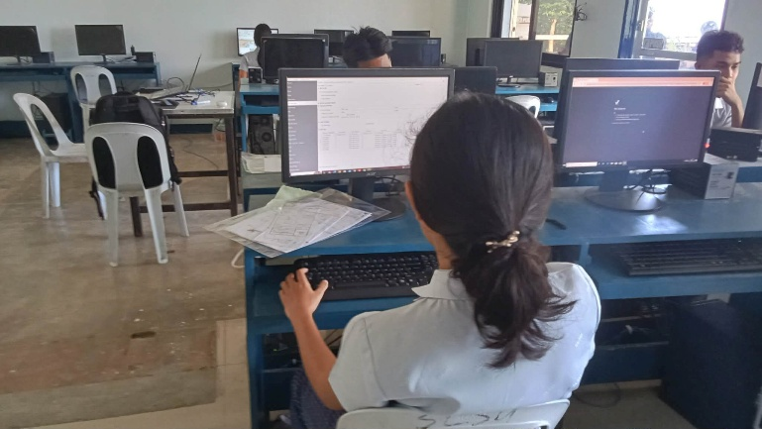

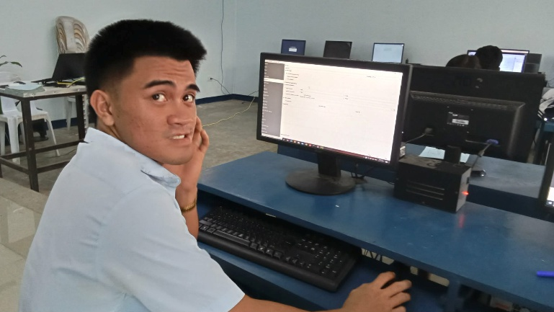
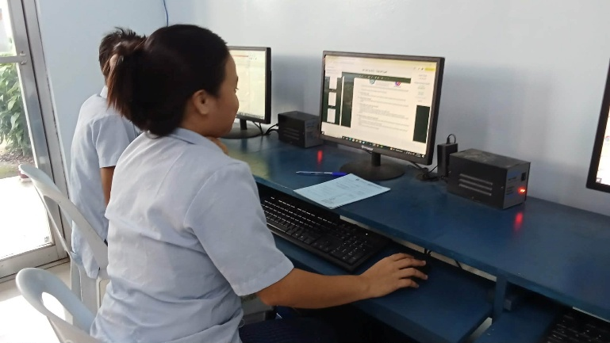

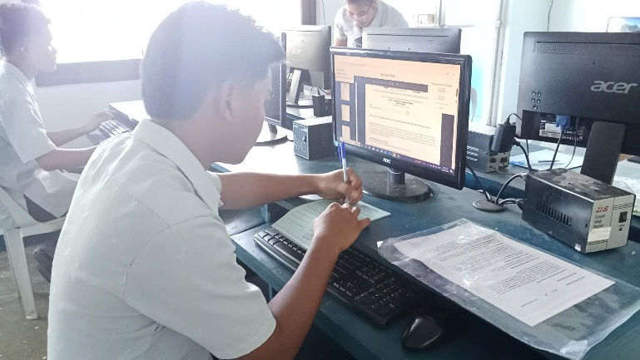
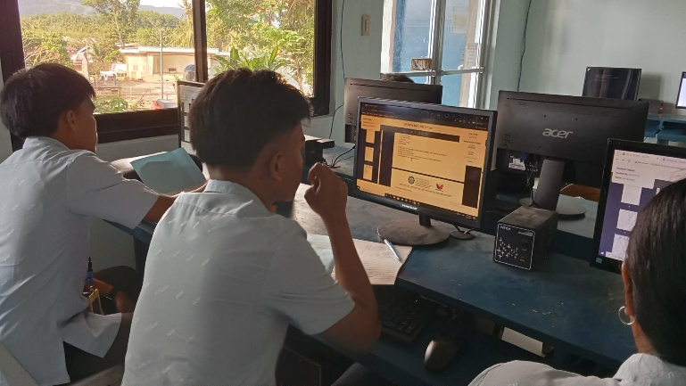

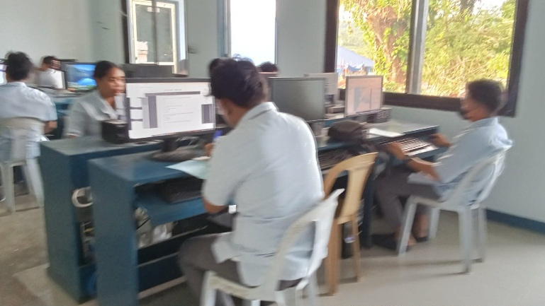
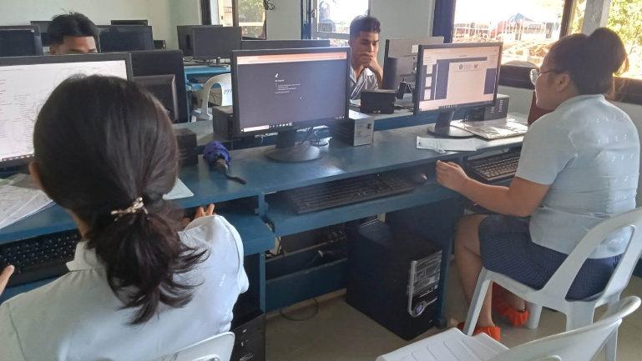

Prepared by: Approved:

JUNNIE RYH M. SUMACOT SHERWIN G. CADAY, PhD.
Instructor Program Chair

